
Sunday | Monday | Tuesday | Wednesday | Thursday | Friday | Saturday
 |  |  |  | 1 | 2  Groundhog Day | 3
4 | 5 | 6 | 7 | 8 | 9 | 10
11 | 12 | 13  Mardi Gras | 14  Valentine’s Day | 15 | 16  Chinese New Year | 17
18 | 19  Presidents’ Day (US) | 20 | 21 | 22 | 23 | 24
25 | 26 | 27 | 28

The Regency Club – River Edge |  |  |  | 9:30 Test Your February IQ  10:30 Games We Play  11:30 Tap to Tunes Fitness  Party with Joe Paris  3:00 Celebrate Freedom Day    3:30 Decorating with Candy  4:15 Hula in the Coola  5:30 Late Night with Letterman | GROUNDHOG DAY  9:30 News Coverage  10:30 Golf on the Green  11:30 Friday Fitness  Move and Groove with  Alan & Eve  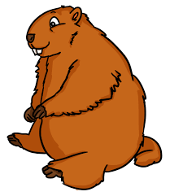  3:00 PUNXY Bingo  3:30 Groundhog Races  4:15 Who am I?  5:00 Evening Movie
Super Bowl Sunday    Pre-Game  Kick Off Event  Touchdown Games  Game Day Punch &  Finger Foods  Funny Commercial Highlights  Football Back in Your Day | 9:30 Fabled Headlines  10:30 Celebrate:  African American History Month  11:30 Daily Fitness Fun  Sing & Dance with  Frankie M.  3:00 Early Birds  3:30 Word Games  4:15 Shuffleboard  5:00 Table Topics | 9:30 Humor Lines  10:30 Relay Races  11:30 Senior Stretches  2:00 Disco Dance Party    3:00 Queens Day  3:30 Card Sharks  4:15 Parachute Challenge  5:00 Test Your Geography | 9:30 Victorian Valentines  10:30 Reminisce:  Charles Dickens  11:30 Work It Out Exercise  Favorite Hits with  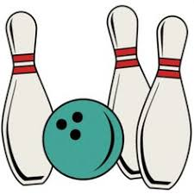  Mary Beth  3:00 Heads Up!  3:30 Beatlemania  4:15 Bowling Club  5:00 Remember When? | Regency Winter Olympics    Join us for a day of physical and intellectual Olympic games, a wintery sweet treat, and a live performance from Bobby Brescia!  We’ll also be awarding our members with gold, silver, and bronze medals!  Don’t miss it! | 9:30 What’s Trending  10:30 Mural Art  11:30 Sit, Sing, Swing Exercise  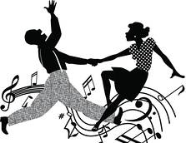  Classics with  Clare Maloney  3:00 Cooking Club  3:30 Reminisce: John Williams  4:15 Charades  5:00 Movie Sing-Alongs
Lovely Sunday  Delicious Red & Pink Breakfast  “Light-Hearted” Brain Games    Lovely Creative Art Project  Love Songs  Candlelight Dinner | 9:30 Finishing Lines  10:30 Short Stories  11:30 Monday Moves  Jump & Jive with  Muzic N’ Motion  3:00 Celebrate Oglethorpe Day  3:30 Dog Show Days – Bring in  a picture of your pooch to share!  4:15 Kickball Challenge  5:00 Reminisce: Abe Lincoln | MARDI GRAS  Celebrate Mardi Gras with The Regency! We’re having a wild party filled with masks, beads, king’s cake, a parade, and jazz dance party!  Let the good times roll!   |   VALENTINE’S DAY  Join us for a day of love!  A Hearty Breakfast  Sweetheart Trivia  Favorite Famous Couples  Valentine’s Sweets  Love Songs with Lou Parisi | 9:30 Cranium Crunches  10:30 Horseracing  11:30 Fab & Fit Workout  Rock Out with Lester Smith  3:00 Member Birthday Bash    3:30 Reminisce: Susan B. Anthony  4:15 Card Players Club  5:30 Radio Hour |   Ring in the Chinese New Year!  Superstitions & Traditions  Chopstick Relay Races  Origami Demonstration  Authentic Chinese Treats  Showtime with  Stiletto & the Saxman
9:30 Morning News  10:30 Daytona 500  11:00 Senior Zumba  2:00 Ladder Golf Tournament  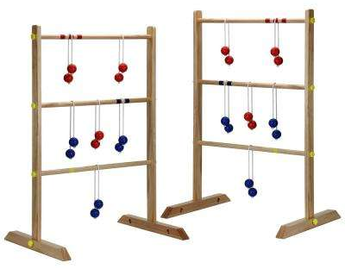  3:00 Wine & Cheese Social  3:30 Meditative Art  4:15 Celebrity Match Game  5:00 Roll the Dice | 9:30 Presidential Trivia  10:30 Honest Abe Craft  11:30 Sit & Be Fit  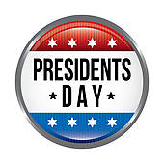  Terrific Tunes with  Val & Ken  3:00 Patriotic Snack  3:30 Name That President  4:15 Who Am I? First Ladies  5:00 Famous Presidential Pets | 9:30 Brain Twisters  10:30 Yarn Art  11:30 Shake It Up Exercise  AARP Idol Winner: Julian!  3:00 Baking Club  3:30 Ansel Adams Photography  4:15 Ansel Adams Photography  5:00 Sing-Along Songs | 9:30 Senior Poetry  10:30 Corn Hole  11:30 Warmup Workout  2:00 Volleyball Tournament  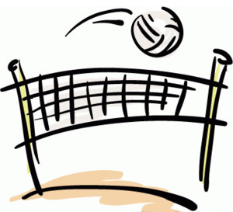  3:00 Pictionary  3:30 Trivial Pursuit  4:15 Spa Relaxation  5:00 Toss & Talk | 9:30 Hand Massages  10:30 Tech Savvy Seniors  11:30 Boogie & Bounce Fitness  Sinatra Favorites with  Frankie Sands  3:00 Drama Club  3:30 HBD George Washington  4:15 Frisbee Throw  5:00 You Be the Judge | 9:30 Jokes & Riddles  10:30 Big Cheese Throw  11:30 Fun Friday Workout  Boogie Down with  Lou Bernardi  3:00 Girl Scout Cookie Social  3:30 Famous Comedians  4:15 Balloon Badminton  5:00 Bloopers
9:30 Literary Recall  10:00 Heads Up!  11:30 Move & Groove Exercise  2:00 Wii Sports    3:00 Famous Painters  3:30 Indoor Walking Club  4:15 The Marx Brothers  5:00 Senior Trivia | 9:30 Horoscopes  10:30 Walk the Line  11:30 Senior Yoga  Dance Party with  Dennis Grau  3:00 Fables & Folktales  3:30 Horseshoes  4:15 Scattergories  5:00 Line Dancing | 9:30 Word Scramble  10:30 Target Throw  11:30 Zumba Fitness  2:00 Goal Kick Challenge  3:00 Reminisce: Elizabeth Taylor  3:30 Travelogues  4:15 Tabletop Games  5:00 Would You Rather? |   The Great Gatsby  Party like it’s the ‘20s!  Play Casino Games!  Win the Raffle and Prizes!  Enjoy Hors d’ oeuvres & Mocktails!  Dance with Chris Durante!  Join us for a roaring good time!  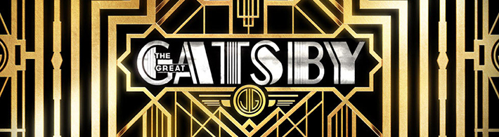 | Happy Birthday!
  Sal B. 4th | Marie-Louise H. 7th
  Lillian H. 4th | Jeannette R. 8th
  Maryanne P. 5th | Rosemarie M. 20th
  Ken G. 6th | Josephine C. 24th
  Faith H. 6th | Lydia H. 24th
*Outings this month: Franco’s Metro, Coach House, Paterson Museum, Maggiano’s, Red Robin, Dynasty Buffet, Charlie Brown’s, Franco’s Metro, African Art Museum, Joyce Chinese, Cubby’s BBQ, Parkway Lanes *All activities are subject to change without notice

